Grade 7 Accelerated · Unit 4 · Lesson 4  Real-World Problems and Significant Digits  Question Bank 4.04 ANSWER KEY | Name  Date  Period

Show your work. Circle your final answer.
For questions 1 through 4, give the number of significant digits in each measurement.
1. 4,207 grams
4
Every digit counts: the zero sits between two nonzero digits.

2. 0.0058 meters
2
Leading zeros are never significant.

3. 3.200 seconds
4
The trailing zeros count, because a decimal point is written. 3.200 and 3.2 are the same number but not the same claim.

4. 52,000 litres
2
No decimal point is written, so the trailing zeros are only holding places.

For questions 5 through 8, solve. Report each answer with the correct precision.
5. A rectangular plot measures 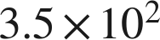 m by 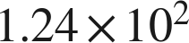 m. Find its area.
 square meters
43,400 exactly; 2 significant digits and 3, so the answer keeps 2.

6. A car travels 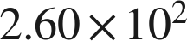 km in 3.0 hours. Find its average speed.
 km/h
260 ÷ 3.0 = 86.66…; 3 significant digits and 2, so the answer keeps 2.

7. Two lengths are measured: 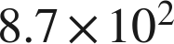 mm and 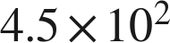 mm. Find their sum.
 mm
870 and 450 both stop at the tens place, so the sum, 1,320, does too. A sum can carry more significant digits than either measurement — three here, from two twos.

8. Two masses are measured: 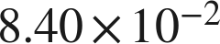 g and 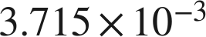 g. Find their difference.
 g
0.080285 exactly; 0.0840 stops at the ten-thousandths place and 0.003715 stops two places further out, so the answer stops at the ten-thousandths.

Real quantities.
9. The Amazon River discharges about  gallons of water each second.
a. How many gallons does it discharge in one hour, which is  seconds? Report the answer with the correct number of significant digits.
 gallons
 exactly. The rate carries two significant digits; 3,600 seconds in an hour is an exact conversion, not a measurement, so it does not limit the count. The answer keeps two.
b. A second river discharges about  gallons per second. How many times larger is the Amazon's rate? Report the answer with the correct number of significant digits.
5.0 times larger
Exactly 5; two significant digits are justified, so it is written 5.0.

10. A processor performs about  calculations each second.
a. How many calculations does it perform in one minute? Report the answer with the correct number of significant digits.
 calculations
. Sixty seconds in a minute is exact, not a measurement, so it does not limit the count — the answer keeps the measurement's three digits.
b. Five of these processors run for 20 minutes. How many calculations do they perform altogether? Report the answer with the correct number of significant digits.
 calculations
. Five and twenty are counts, so again only the measurement's three digits survive.

Reading someone else's work.
11. Omar multiplies a measured length of 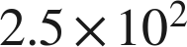 m by a measured width of 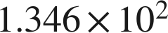 m and reports the area as 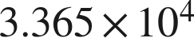 square meters. Is his arithmetic correct? Is his answer correct? Explain.
His arithmetic is correct — the exact product is . His answer is not, because 2.5 carries only two significant digits, so the area can carry only two:  square meters.
A correct value in the wrong form is still the wrong answer here; the rule is part of the question.

12. A rectangle's sides are measured as  cm and  cm. Which is the area, in scientific notation with the correct number of significant digits?
○ A. 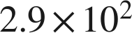 cm²
○ B. 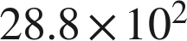 cm²
● C.  cm²
○ D. 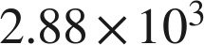 cm²
C

